IDP for JAVA PIPELINE

INFOSYS LTD,
Bengaluru.

Document No. : | IDP_OSS/Doc :D09 | Version.Rev : | 1.00
Authorized by: |  | Date

COPYRIGHT NOTICE

© 2018 - 2019 Infosys Limited, Bengaluru, India. All Rights Reserved. Infosys believes the information in this document is accurate as of its publication date; such information is subject to change without notice. Infosys acknowledges the proprietary rights of other companies to the trademarks, product names and such other intellectual property rights mentioned in this document. Except as expressly permitted, neither this documentation nor any part of it may be reproduced, stored in a retrieval system, or transmitted in any form or by any means, electronic, mechanical, printing, photocopying, recording or otherwise, without the prior permission of Infosys Limited and/or any named intellectual property rights holders under this document.

Infosys Limited
Electronics City,
Hosur Road,
Bengaluru 560 100
India.
Telephone: 91 80 2852 0261
Fax: 91 80 2852 0362
Website: http://www.infosys.com

REVISION LIST

Ver.  Rev | Date | Authors | Reviewed  By | Description
0.00a | 3-Sep-2018 | Sumuka B | Krishnakanth B.N.
1.00 | 14-Sep-2018 | Priya.N.K

OVERVIEW

DEVOPS AND IDP
DevOps is the combination of practices, and tools that increases an organization's ability to deliver applications and services at high velocity.
Infosys DevOps Platform (IDP) is a centralized platform to promote DevOps (continuous integration, continuous deployment and continuous testing). This platform can be leveraged for various technologies (Java, .Net, etc.) to schedule automated builds along with validations such as code analysis, unit testing, code coverage analysis, open source compliance check, obfuscation, Automated testing etc.
This document shows how operations for a java project (Build, deploy, testing) can be automated using IDP and a dashboard to show the status of each step in a graphical representation.

FUNCTIONALITY

CONTINUOUS INTEGRATION
Goal of the CI is to provide rapid feedback so that a defects can be identified and corrected ASAP. IDP supports CI in java project by doing compile, Unit testing, code analysis and code coverage with the help of various tools (Described in the Usage section.)

CONTINUOUS DEPLOYMENT
CD aims to reduce the time elapsed between writing a line of code and making that code available to users in production. IDP supports Tomcat, WebSphere deployments and deploy to Docker containers.

CONTINUOUS TESTING
Continuous Testing is the process of executing automated tests as part of the software delivery pipeline in order to obtain feedback on the business risks associated with a software release. IDP supports functional and non-functional tests (performance, security etc.) with help of various tools (Described in the Usage section.)

DASHBOARD
Dashboards often provide at-a-glance views of KPIs (key performance indicators) relevant to a particular objective or business process. IDP provides a unified dashboard built on open source Grafana for visibility across DevOps pipeline.

USAGE

CREATING PIPELINE For The Application
LOGIN PAGE
- Login to IDP using active directory credentials.



Figure 1: Login Page

- On successful login, we will be redirected to the History Page which would show us a list of pipelines that created from the id.

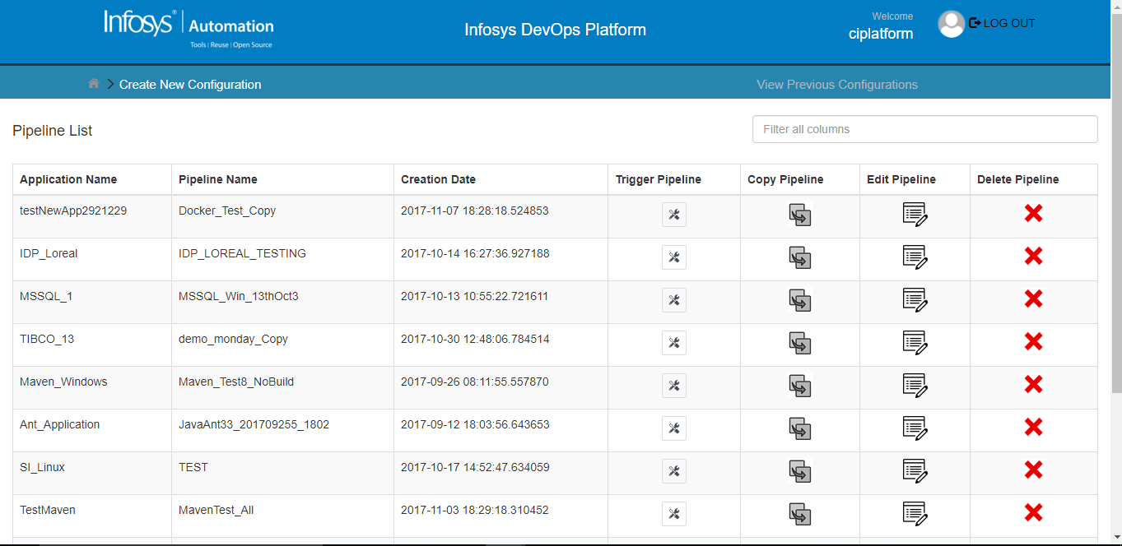

Figure 2: Previously created pipelines Page

BASIC INFO PAGE
PIPELINE CREATION

Select the Application Name under which the “Pipeline” has to be created. Give a unique name for the “Pipeline”. Select the Build Server OS on which the “Pipeline” will be executed.

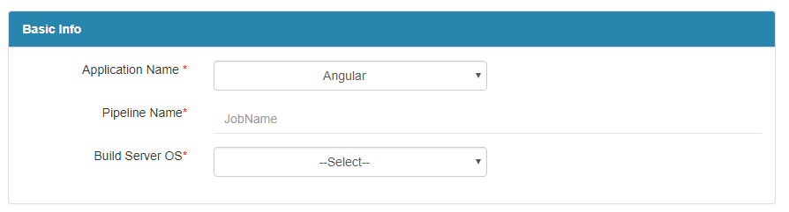

Figure 3: Basic Info Page-Pipeline Details

ADDITIONAL MAIL RECIPIENTS

This is an optional section where you can choose to send the notification emails to specific people. If All Application Users checkbox is selected, then mail is sent to all the users mentioned in that application. Click Continue Button to navigate to the next page or Click Reset Button to reset the contents of the current page.

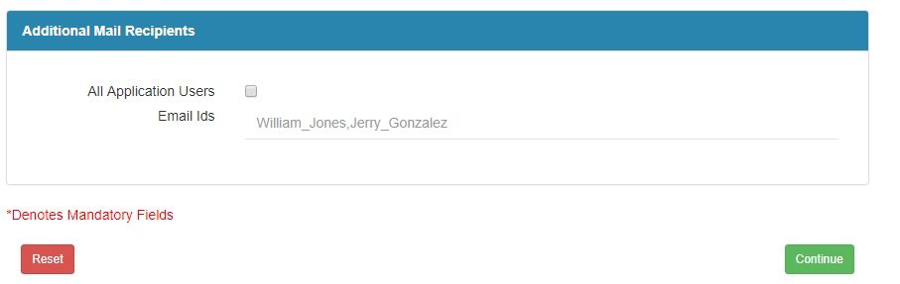

Figure 5: Basic Info- Additional Mail Recipients

CODE INFO PAGE
TECHNOLOGY AND SCM DETAILS
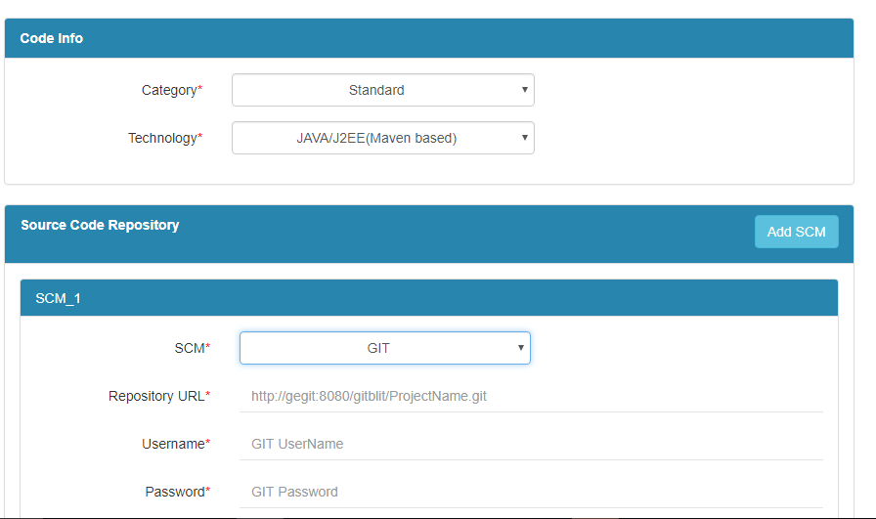

Figure 6: Code Page - Technology & SCM Details

Select the technology [Java/J2EE (Maven Based)]. Then configure the SCM tool used in the project. Select the SCM from where Source code has to be pulled out. There are four types of SCM’s in this platform – GIT, IBM RTC, MS TFS and SVN.

USING GIT
If GIT is chosen, then give the repository URL, Username and Password of the person who has right to check out the code from it along with default branch. If directories have to be included explicitly then check the checkbox and mention
directories. Select Repository Browser and its corresponding fields.

Using IBM Rational Team Concert
If IBM RTC is chosen, then give repository URL, RTC Workspace Name and Stream Name along with Username and Password.

Using MICROSOFT TEAM FOUNDATION SERVER

If MS TFS is chosen, then give TFS Server URL, the path of the Project and User credentials.

Using SVN
If SVN is chosen, then give Repository URL, User credentials.

CUSTOM BUILD ACTIONS
This facilitates the custom build actions that needs to be performed before or after the build operations.

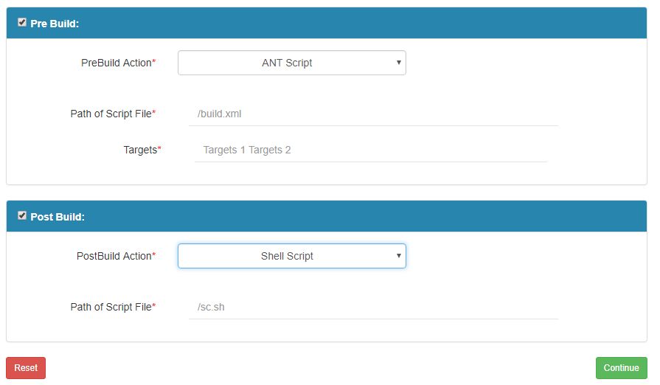

Figure 6: Code Page- Custom Build Actions

Pre Build Action
Any action that needs to be performed before a build action is configured here. Select the Pre Build action. This platform supports ANT Script, Shell Script and Batch Script. Enter the path of the Script file. If ANT script is selected enter the targets. (Ex: init, compile)

Post Build Action
Any action that needs to be performed after build action is configured here.
Select the Post Build action. This platform supports ANT Script, Shell Script and Batch Script. Enter the path of the Script file. If ANT script is selected enter the targets. (Ex: init, compile). Click on CONTINUE Button to navigate to the next page.

ADDITIONAL PIPELINE PARAMETERS

Pipelines can be defined with parameters as these parameters control what the pipeline does. The parameter type can be either string or password type. The password type is encrypted, then provide any name to Parameter and give the value also. Static can be selected if you do not want to change the parameter value at trigger time.
To change the parameter value at trigger time, then the static checkbox need not be checked and this parameter value can be provided in the input box of the trigger page.

BUILD INFO PAGE

This provides the list of operations that can be integrated to the build pipeline, which can be scheduled along with the build operations.

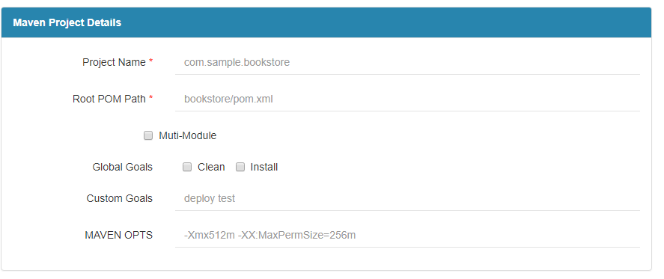

Figure 8: Build Page- Maven Project Details

Enter the Maven Project Name upon which various build/testing operations need to be performed. Enter the relative path to the root POM. If the project is multi module (Multiple maven projects within a single parent), check the checkbox. Select the Global goals if needed:
Clean: Deletes the output of a build by deleting the build directory of earlier created files.
Install: Installs the package in local/remote maven repository.
Enter other custom goals if required and MAVEN OPTS if required.

BUILD OPERATIONS
Select Compile to compile the project.

CODE ANALYSIS

The selection of code analysis checkbox ensures SonarQube, PMD, Checkstyle and to run rules for static code analysis for Maven Project. FindBugs can be selected only if compile is selected.

UNIT TESTING

The selection of Unit testing checkbox ensures the execution of JUnit test cases that are present in the project.

CODE COVERAGE

The selection of Code Coverage checkbox ensures the coverage of JUnit test cases that are present in the project using Cobertura. It can be selected only if Unit Testing is selected. Click on CONTINUE Button to navigate to the next page

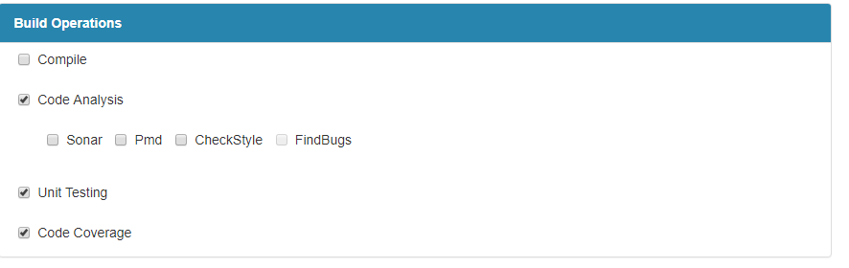
Figure 9: Build Page- Build Operations

DEPLOY INFO PAGE

DEPLOY INFORMATION
Select the environment checkbox to select deployment of the packaged maven project into different application servers in different environments.

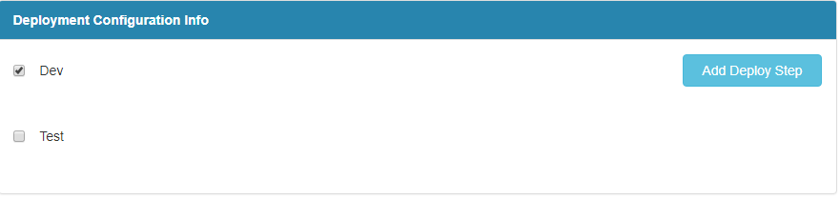
Figure 10: Deploy Page

ADD DEPLOY STEP

- Click on Add deploy Step button at the top-right corner to provide the deployment details for a particular environment.
- Give the Step Name.
- Give Admin username and password and Application username and password if applicable.
- Select Run scripts if required. It provides an option of SNT Script, Shell Script, Batch file, PowerShell and SSH.
- Select one of the three options (Deploy to container/Deploy to Docker Container/Spring boot deployment).
- If Deploy to container is selected, choose the application server from the options:

Using TOMCAT

Provide the Server Manager URL, path of WAR/EAR file relative to the checkout path, Context path for the application that has to be deployed and the credentials.

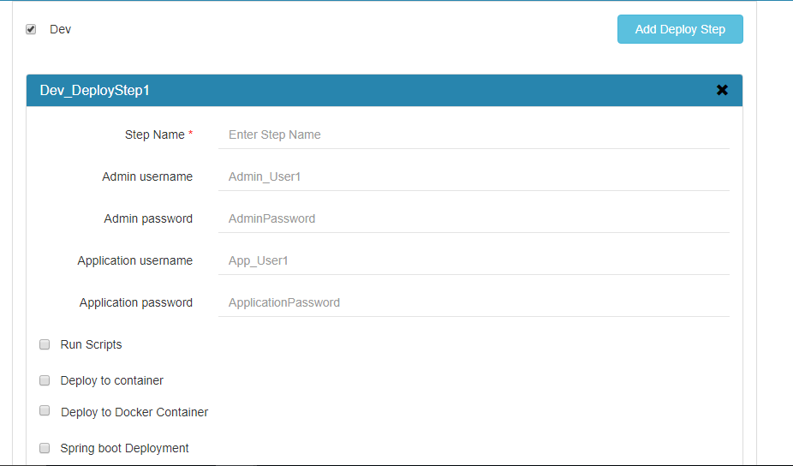
Figure 11: Deploy Page – Deploy Step

USING WebSphere

Provide the WebSphere IP/DNS, path of WAR/EAR file relative to the checkout path. SOAP port to connect to IBM WebSphere Application Server. Enter the Target Cell Name, Target Node Name, Target Server Name where the application that has to be deployed and User credentials.

DEPLOY TO DOCKER CONTAINER

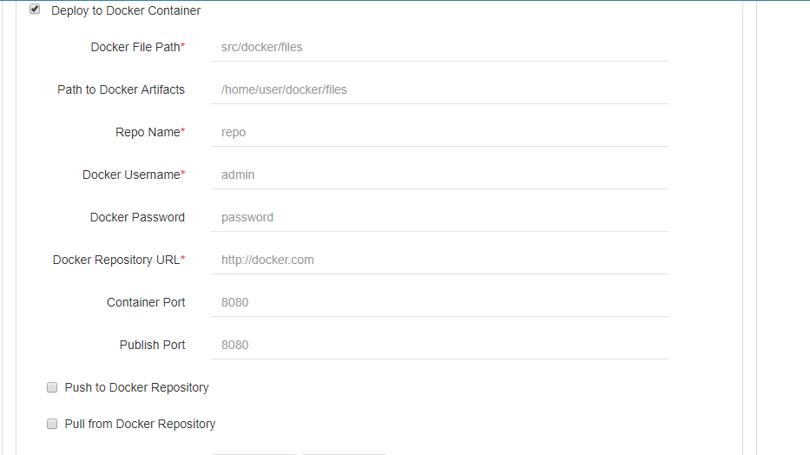
Figure 12: Deploy Page – Deploy to Docker Container

Provide the Docker File path relative to workspace. Give path to docker artifacts where docker artifacts are present if needed, Docker Repo Name, Docker credentials, Docker Repository URL, Container Port and publish port if needed. Select pull/push from repository if required. Add multiple path of artifacts to be deployed.
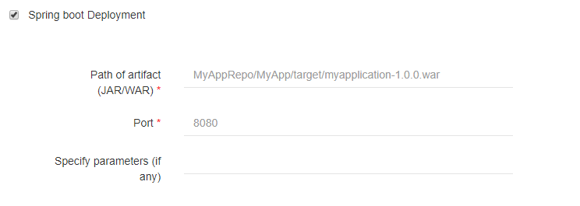
Figure 13: Deploy Page – Spring Boot Deployment

- Give Path of JAR/WAR artifact with jar/war extension.
- Give the Port number.
- Specify parameters if there are any.
- Click on CONTINUE Button to navigate to the next page

TEST INFO PAGE

TEST INFORMATION
Select the environment checkbox to select test environment.
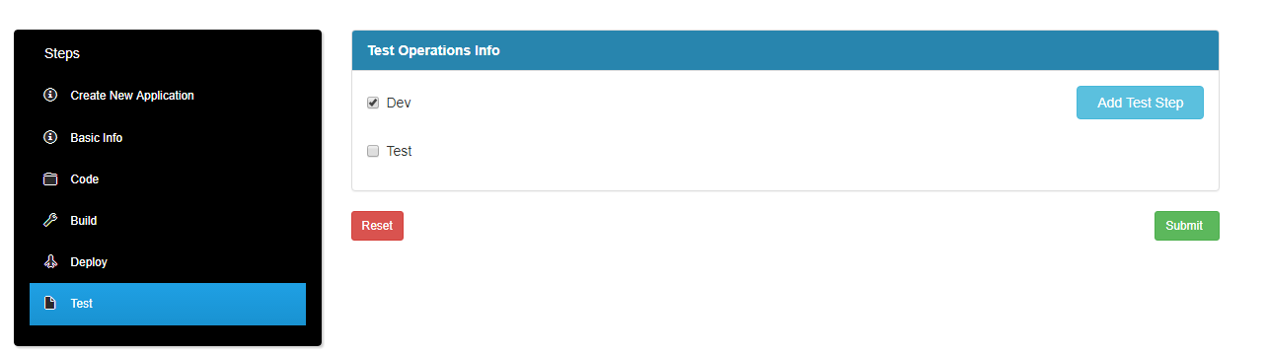
Figure 14: Test Page

ADD TEST STEP

Click on Add Test Step button at the top-right corner to provide the test details for a particular environment. Give the Step Name. Select either Run scripts or Test tool. Select Run Scripts if required. It provides an option of ANT Script, Shell Script, batch file, PowerShell and SSH.
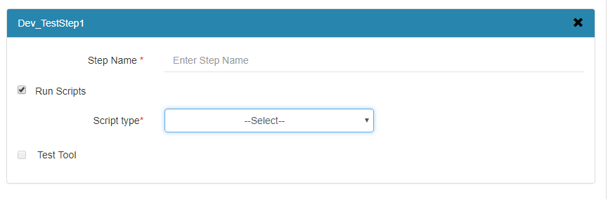
Figure 15: Test Page – Run Scripts selected

SELECT TEST TOOL

Provide the Test Category (Functional/Performance/Security/ Service).

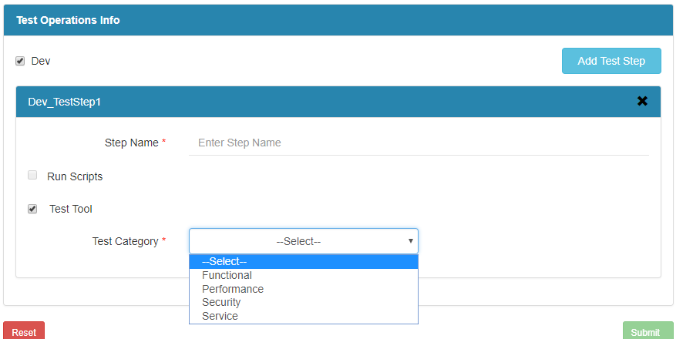
Figure 16: Test Page – Test Tool selected

FUNCTIONAL TESTING
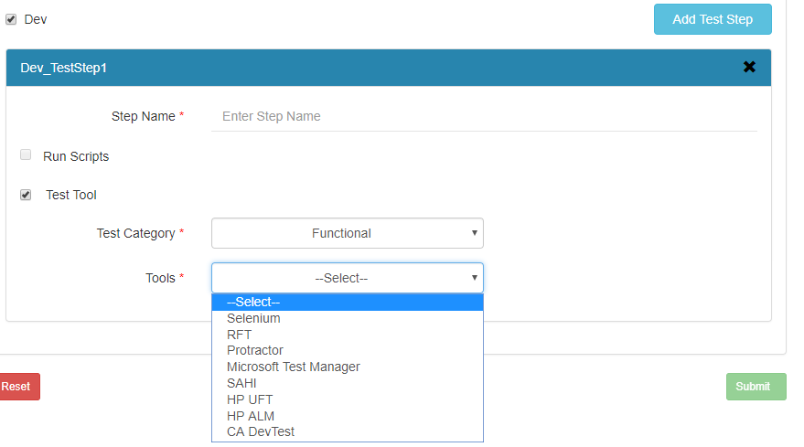
Figure 17: Test Page – Functional Category selected

SELENIUM

Provide the URL of the Application, project path and select the Framework(Junit/TestNG). Provide source path and selenium Test Suite file which has to be executed. If external libraries have to be added, then checkbox that option and provide the directory containing external libraries.

RFT
Provide the project which contains the RFT Test Suite and the RFT Script name which has to be executed.

PROTRACTOR

Provide Config file path.

MTM

Provide the VSTS Project Name, Plan ID, report path.

SAHI
Provide the SAHI Test Suite path, Test URL and select the browser in which this URL has to open to run the Test Suites.

HP UFT

Provide the path of Tests along with Project name and timeout time (approximate time required for the tests to run).

PERFORMANCE TESTING
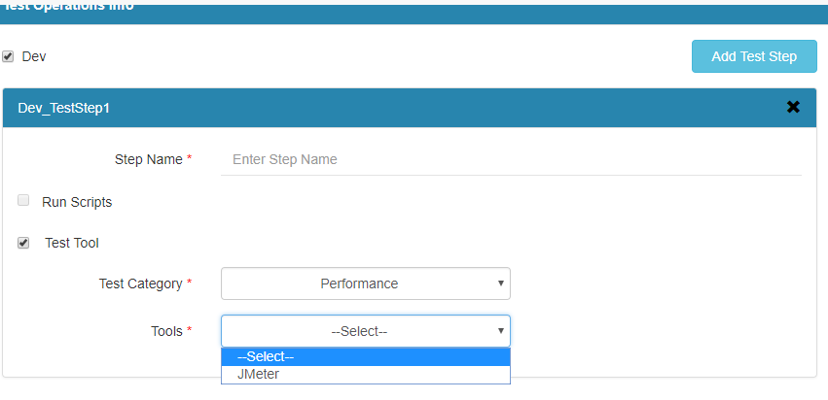
Figure 18: Performance test selected

Using Jmeter

Provide the path of the test plan which has to be executed and the property file if required.

SECURITY TESTING
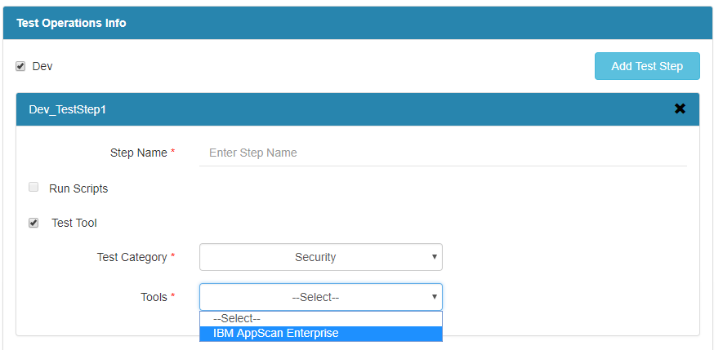
Figure 19: Security testing selected

IBM APPSCAN ENTERPRISE
Provide the URL for the scan to test, user credentials and the “Pipeline” name which has to be executed.

SERVICE TESTING
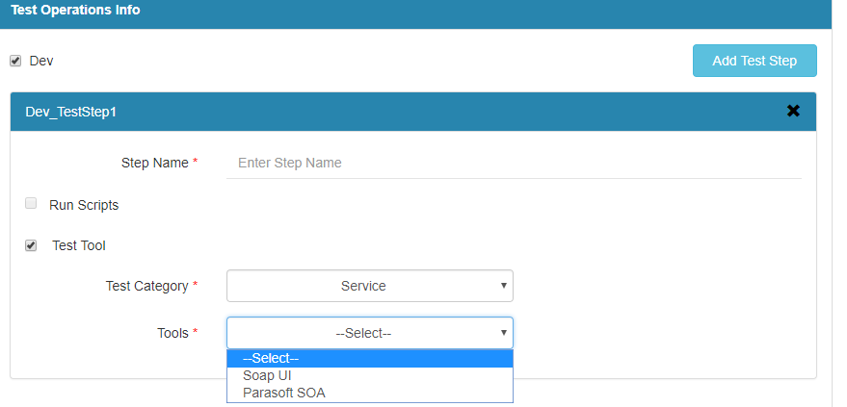
Figure 20: Service testing selected

SoAPUI
Provide the name of the project and location which contains Soap UI Test Suite, then give the name of the Test Suite which has to be executed.

PARASOFT SOA
Provide the name of the project containing Parasoft SOA Test, name of the Parasoft SOA Test project location which has to be executed, name of the Test Suite which has to be executed and name of the test configuration.

SUBMITTING THE PIPELINE
You can now click on Submit button to create a new pipeline.
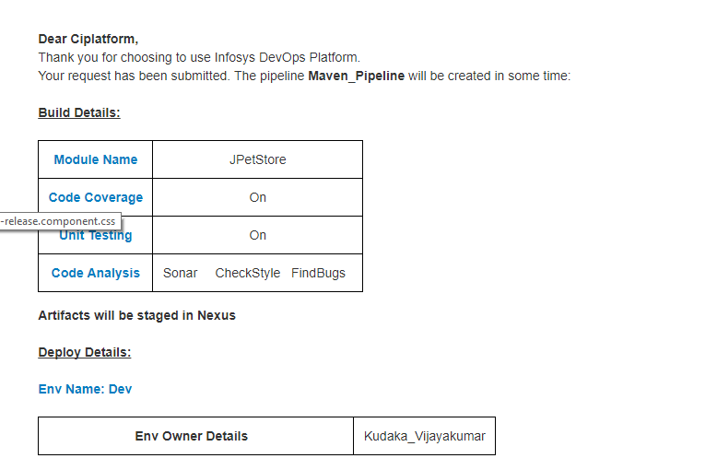

Figure 19.a : Success Page- Project Details

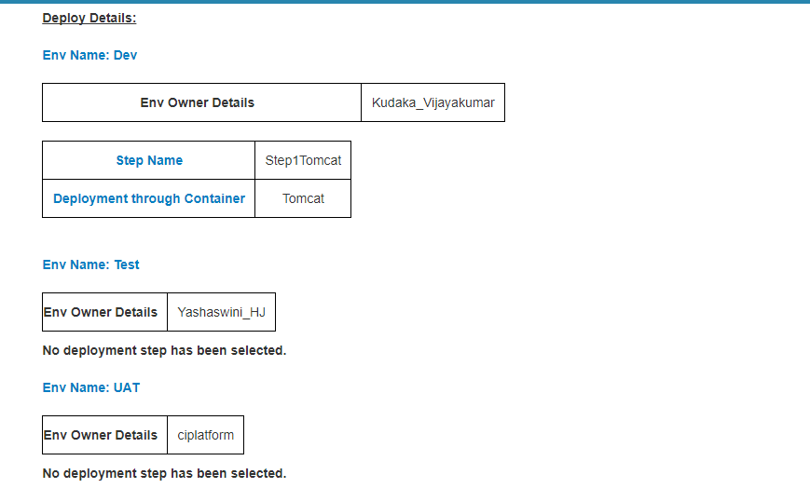

Figure 19.b : Success Page- Deploy Details

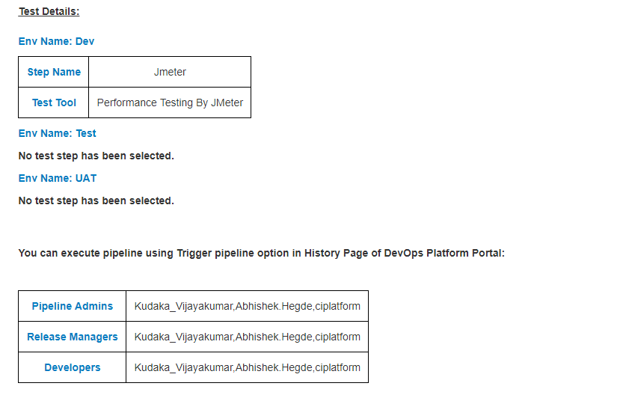

Figure 19.c : Success Page- Test Details

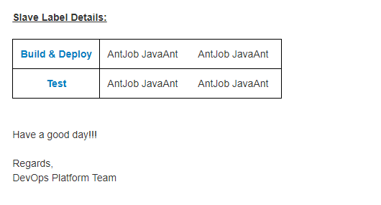
Figure 21 : Success Page- Pipeline agent Details

TRIGERRING THE PIPELINE

- Select pipeline from previous configuration page.
- Trigger Page will open.
- Enter the Release number.
- Select the pipeline agent name for build/deploy/test.
- Select either or all the options from build/deploy/test as per the requirement.
- Click on submit to trigger the pipeline.

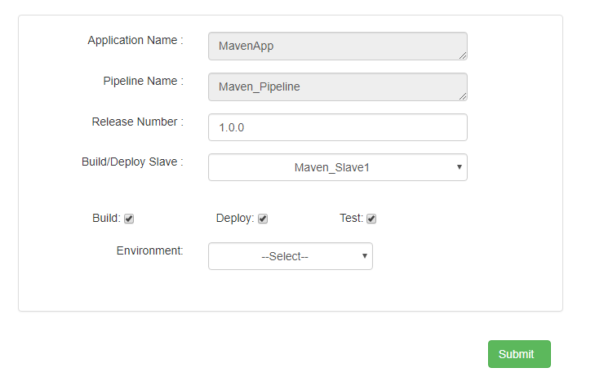
Figure 24 : Trigger Page

